PROG12583_Assignment 1
Revision: 0.2
Author: Dao Nam Thai – Student ID: 991739094
Date: 2024-Feb-03

About the Document

History
Revision | Date | Author | Description
0.1 | 2024-02-03 | Dao Nam Thai | Initial Version
0.2 | 2024-02-04 | Dao Nam Thai | Update data follow new version of source code

Contents
Contents 2
1 Scope 3
2 Part B 4
Requirement: 4
3 Part C 6
3.1. Syntax error 6
3.2. Runtime error 9
3.3. Logical Error 11

- Scope

The aim of this document is to cover requirement of part B and Part C in Assignment 1 (PROG12583)
The report is based on the following the below source code:
- Thai_991739094_Assignment_1st.py
- Revision: commit 0d67c4fc6017bdc4c6089aca4f71426821ad0154

The output of this program:
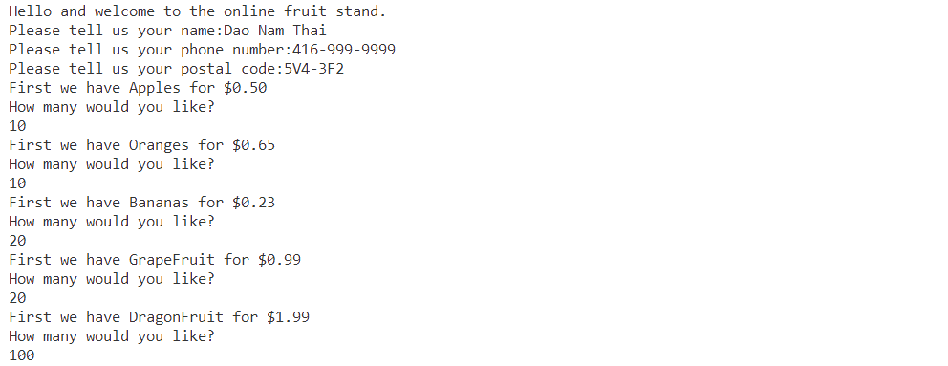
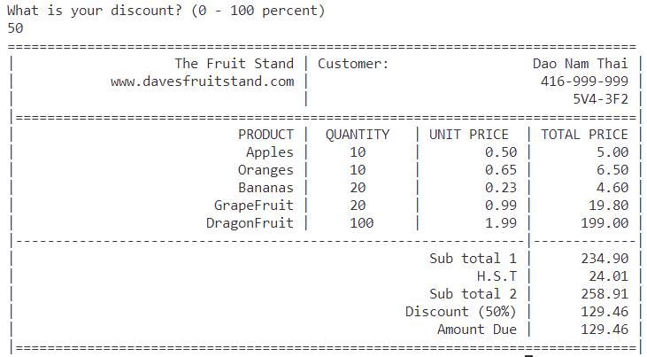
- References:
https://docs.python.org/release/3.2.5/library/string.html#formatspec
https://docs.python.org/3/reference/lexical_analysis.html#keywords
https://docs.python.org/3/genindex-Symbols.html

- Part B
Requirement:
Analyze the source code. Divide the program into keywords, declarations, statements and blocks.

  - Number of keywords used and actual keywords. Research the keyword using your textbooks.

No | Symbol | Example | Count of symbol
1 | if | Assignment operator | 5
2 | or | Equality comparison | 1

  - Number of symbols used and actual symbols. Research the keyword using your textbooks.
Total: 18 symbols are used in source code (exclude comment source code)

No | Symbol | Name | Count of symbol
1 | = | Assignment operator | 41
2 | == | Equality comparison | 4
3 | += | Increment assignment | 0
4 | - | Subtraction | 1
5 | > | Greater than | 36
6 | < | Less than | 1
7 | : | Colon | 42
8 | “ | Double quotation mark | 86
9 | ‘ | Single quotation mark | 124
10 | # | Comment | 58
11 | () | Parenthesis | 96
13 | [] | Square brackets | 3
14 | , | Comma | 56
15 | . | Dot | 32
16 | {} | Curly braces | 17
17 | % | Percent | 48
18 | / | Division mark | 1

- Number of predefined Python program elements and the actual elements themselves. Identify what kind of element it is (e.g. variable, function/method, class, and module)

No | Predefined |  | Count of predefined
1 | print | Print objects to the stream file | 30
2 | input | The function then reads a line from input, converts it to a string | 6
3 | int | Convert a number or string x to an integer | 5
4 | float | Convert a string or a number to floating point. | 1
5 | format | Convert a value to a “formatted” representation, as controlled by format_spec | 37
6 | strip | Return a copy of the string with the leading and trailing characters removed | 3
- Part C
Requirement: Attempt to cause syntax, runtime and logical / semantic errors
1 Change code in the source file with the intent of causing errors. Explain / show what you have
changed. Note and identify any changes that happen right away in VSCode editor.
2. After each change, attempt to run the program and note the error produced if any.
3. Each time, record / show the resulting error displayed by the Python interpreter such that it is clear what change caused what error.
4. Identify the type of error produced and explain why you think it is of that type.
5. Attempt as many different errors as possible. The minimum number of errors is 5. It should also be at least one error for each error type, syntax, runtime and logical.
  - Syntax error
Error 1:
Before:
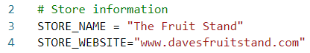
After:
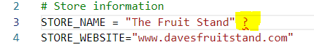
Result error:
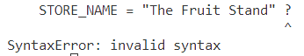
Explain: This is syntax error because the “?” is not allowed in this position.

Error 2:
Before:
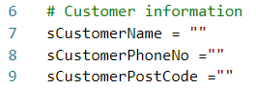
After:
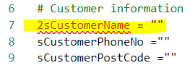
Result of error:
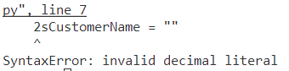
Explain: This is syntax error because name of variable “2sCustomerName” is not corrected. Number ‘2’ is not allowed in the first place of variable name.

Error 3:
Before:
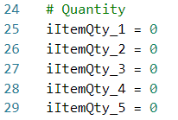
After:
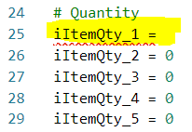
Result of error:
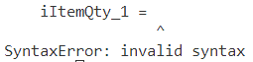
Explain: This is syntax error because the iItemQty_1 is not assigned.

Error 4:
Before:
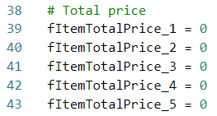
After:
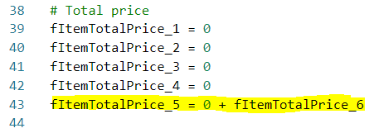
Result of error:
Explain: This is syntax error because the fItemTotalPrice_6 is not defined in anywhere before used in line 43

Error 5:
Before:
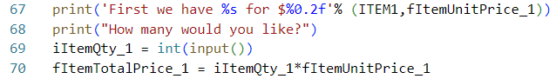
After:
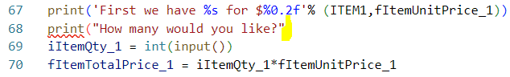
Result of error:
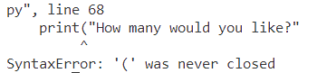
Explain: This is syntax error because missing ‘)’ at the end of statement at line 68

  - Runtime error
The error are happened when running application

Error 1:
Before:
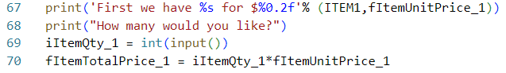
After:
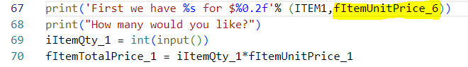
Result of error:
Explain: This is runtime error is happened because fItemUnitPrice_6 is not defined before trying to print.

Error 2:
Before:
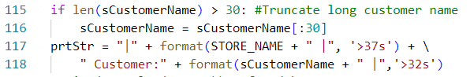
After:
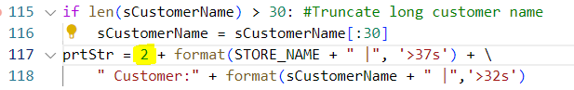
Result of error:
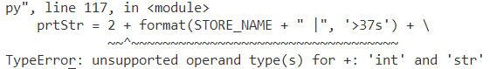

Explain: This is runtime error is happened because concatenating a string with an integer is not supported.

Error 3:
Before:
After:
Result of error:
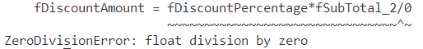

Explain: This is runtime error is happened because trying divide by zero.

Error 4:
Before:
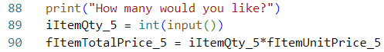
After:
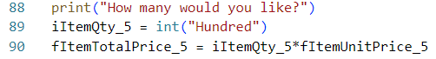
Result of error:
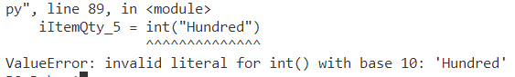

Explain: This is runtime error is happened because trying to convert a string that is not a valid integer representation to an integer.

Error 5:
Before:
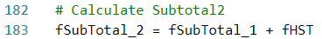
After:
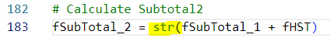
Result of error:
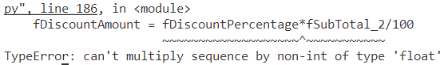

Explain: This is runtime error is happened because fSubTotal_2 is string. Multiplying a string and float is not allowed.

  - Logical Error

Error 1:
Before:
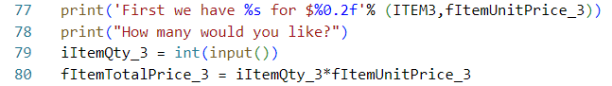
After:
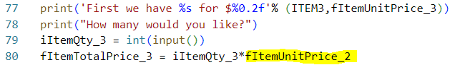

Result of error and explanation:
fItemTotalPrice_3 is wrong because the algorithm was wrong.

Error 2:
Before:
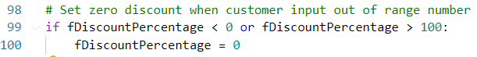
After:
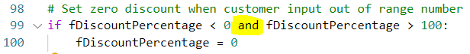

Result of error and explanation:
Logic operator is not corrected. No value of fDiscountPercentage is satisfied these conditions.
Error 3:
Before:
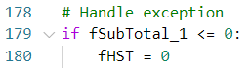
After:
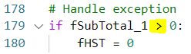

Result of error and explanation:
fHST can’t be assigned by 0 when fSubTotal_1 > 0

Error 4:
Before:
After:
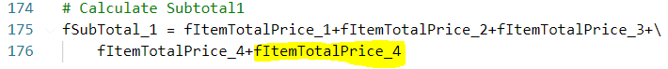

Result of error and explanation:
Using wrong formula to calculate fSubTotal_1

Error 5:
Before:
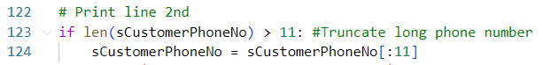
After:
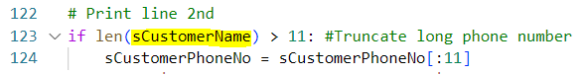

Result of error and explanation:
Using wrong condition to check length of sCustomerPhoneNo

